Subject here…
Proposal document for XXXXXXXXXXXX
9th September 2015

Contents
Summary of your needs 3
Learning Process – Example 4
Learning Process – Before 5
Learning Process – During 6
Learning Process – After 7
Learning Content 8
Learning Content – Before 9
Learning Content – During 10
Learning Content – After 11
Your investment and return 12
Return on Investment 12
Why Global Integration? 13
Heading test 14
Subtitle test 14

Summary of your needs
Lorem ipsum dolor sit amet, consectetur adipisicing elit, sed do eiusmod tempor incididunt ut labore et dolore magna aliqua. Ut enim ad minim veniam, quis nostrud exercitation ullamco laboris nisi ut aliquip ex ea commodo consequat. Duis aute irure dolor in reprehenderit in voluptate velit esse cillum dolore eu fugiat nulla pariatur. Excepteur sint occaecat cupidatat non proident, sunt in culpa qui officia deserunt mollit anim id est laborum.
Lorem ipsum dolor sit amet, consectetur adipisicing elit, sed do eiusmod tempor incididunt ut labore et dolore magna aliqua. Ut enim ad minim veniam, quis nostrud exercitation ullamco laboris nisi ut aliquip ex ea commodo consequat. Duis aute irure dolor in reprehenderit in voluptate velit esse cillum dolore eu fugiat nulla pariatur. Excepteur sint occaecat cupidatat non proident, sunt in culpa qui officia deserunt mollit anim id est laborum.
Yours,
Kevan Hall
CEO Global Integration
kevan@global-integration.com

Learning Process – Example
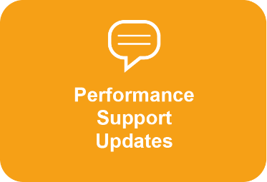
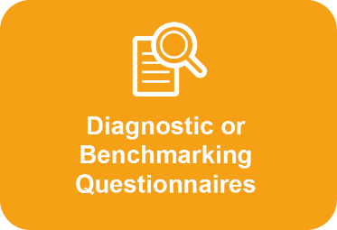
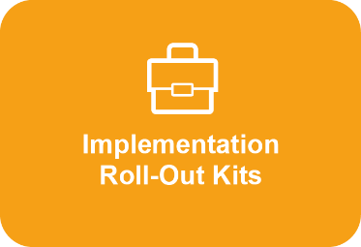

Learning Process – Before

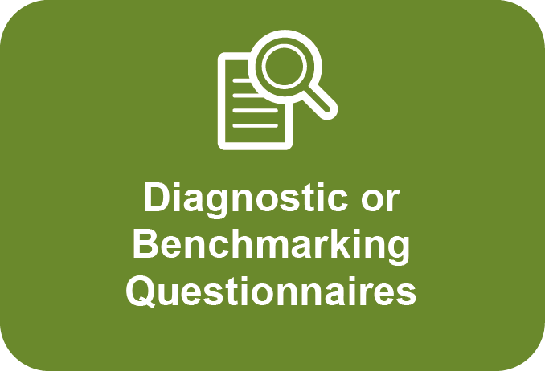

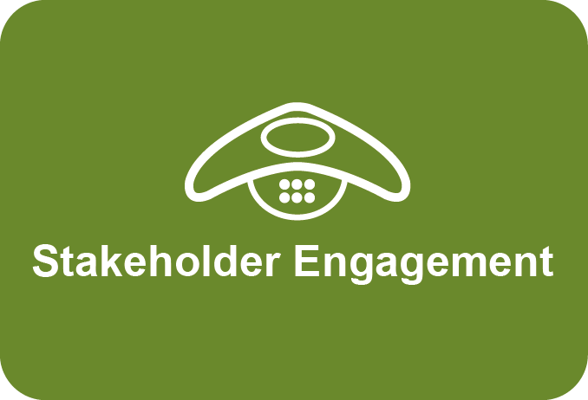

Learning Process – During

Learning Process – After
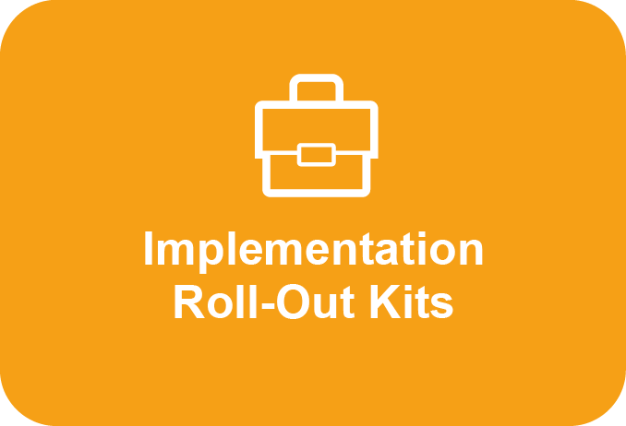
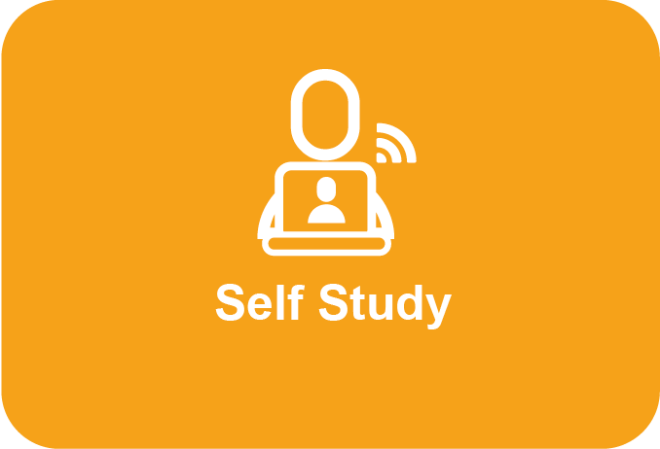
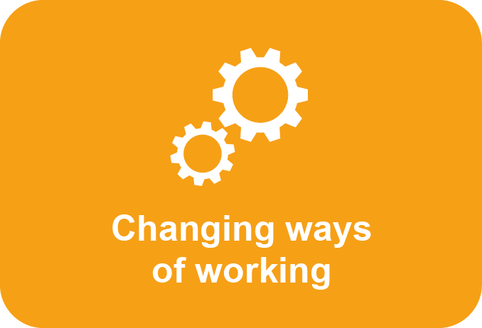
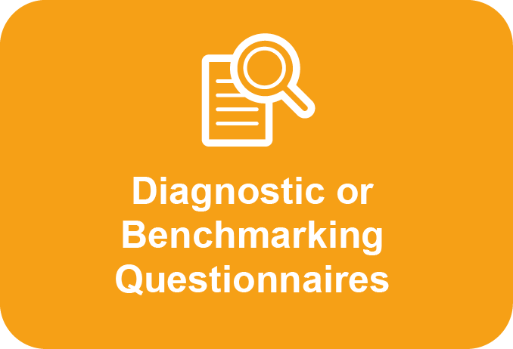
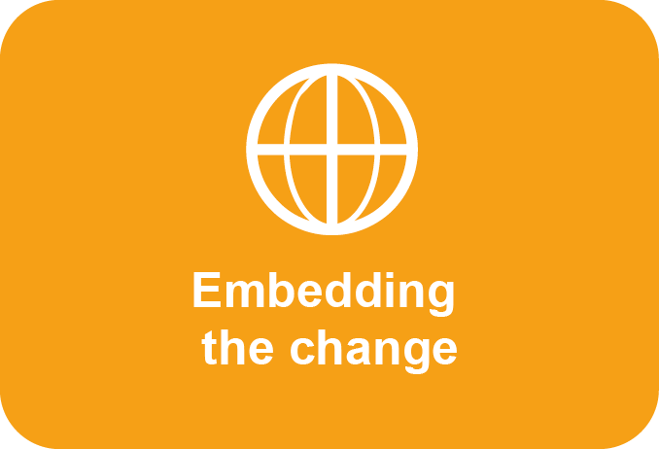
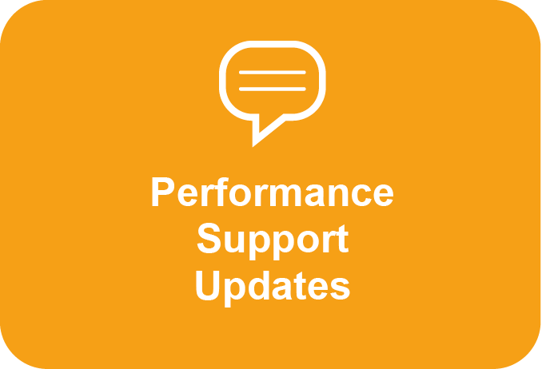

Learning Content

Component | Detail (purpose, process, timing)

Learning Content – Before

Component | Detail (purpose, process, timing)

Learning Content – During

Component | Detail (purpose, process, timing)

Learning Content – After

Component | Detail (purpose, process, timing)

Your investment and return
Our fees for (optional) additional design and development time would be £4,000 per day. These are not payable if you go ahead based on the draft proposal above.
- Access to pre-work videos and materials
- Delivery of a 1.5 day face to face event
- Participant licensing to use our tools and materials
- Copies of all participant materials, wall charts and a copy of our book Speed Lead – faster, simpler ways to manage people, projects and teams in complex companies.
- Access to the 2 follow up video/podcast/download modules with additional content on communication through technology and staying visible when working remotely for participant’s use only

The delivery of the learning process described in the draft proposal would include:
The cost for this would be £635 per participant (subject to a minimum of 15 participants).
(Cost per participant should be the default for programs unless there is a good reason to use another method)
This does not include consultant expenses and any costs such as shipping, venue costs etc... which we recharge at cost.

Return on Investment
The tools in our programs enable participants to deliver faster, cut out unnecessary work and increase engagement. Participants typically achieve payback if, in the whole of the rest of their careers, they:
- avoid one short-haul business trip
- accelerate a critical project by a few days
- cancel one unnecessary meeting.

We are happy to work with you on specific actions and changes you want to drive in your team or organization.

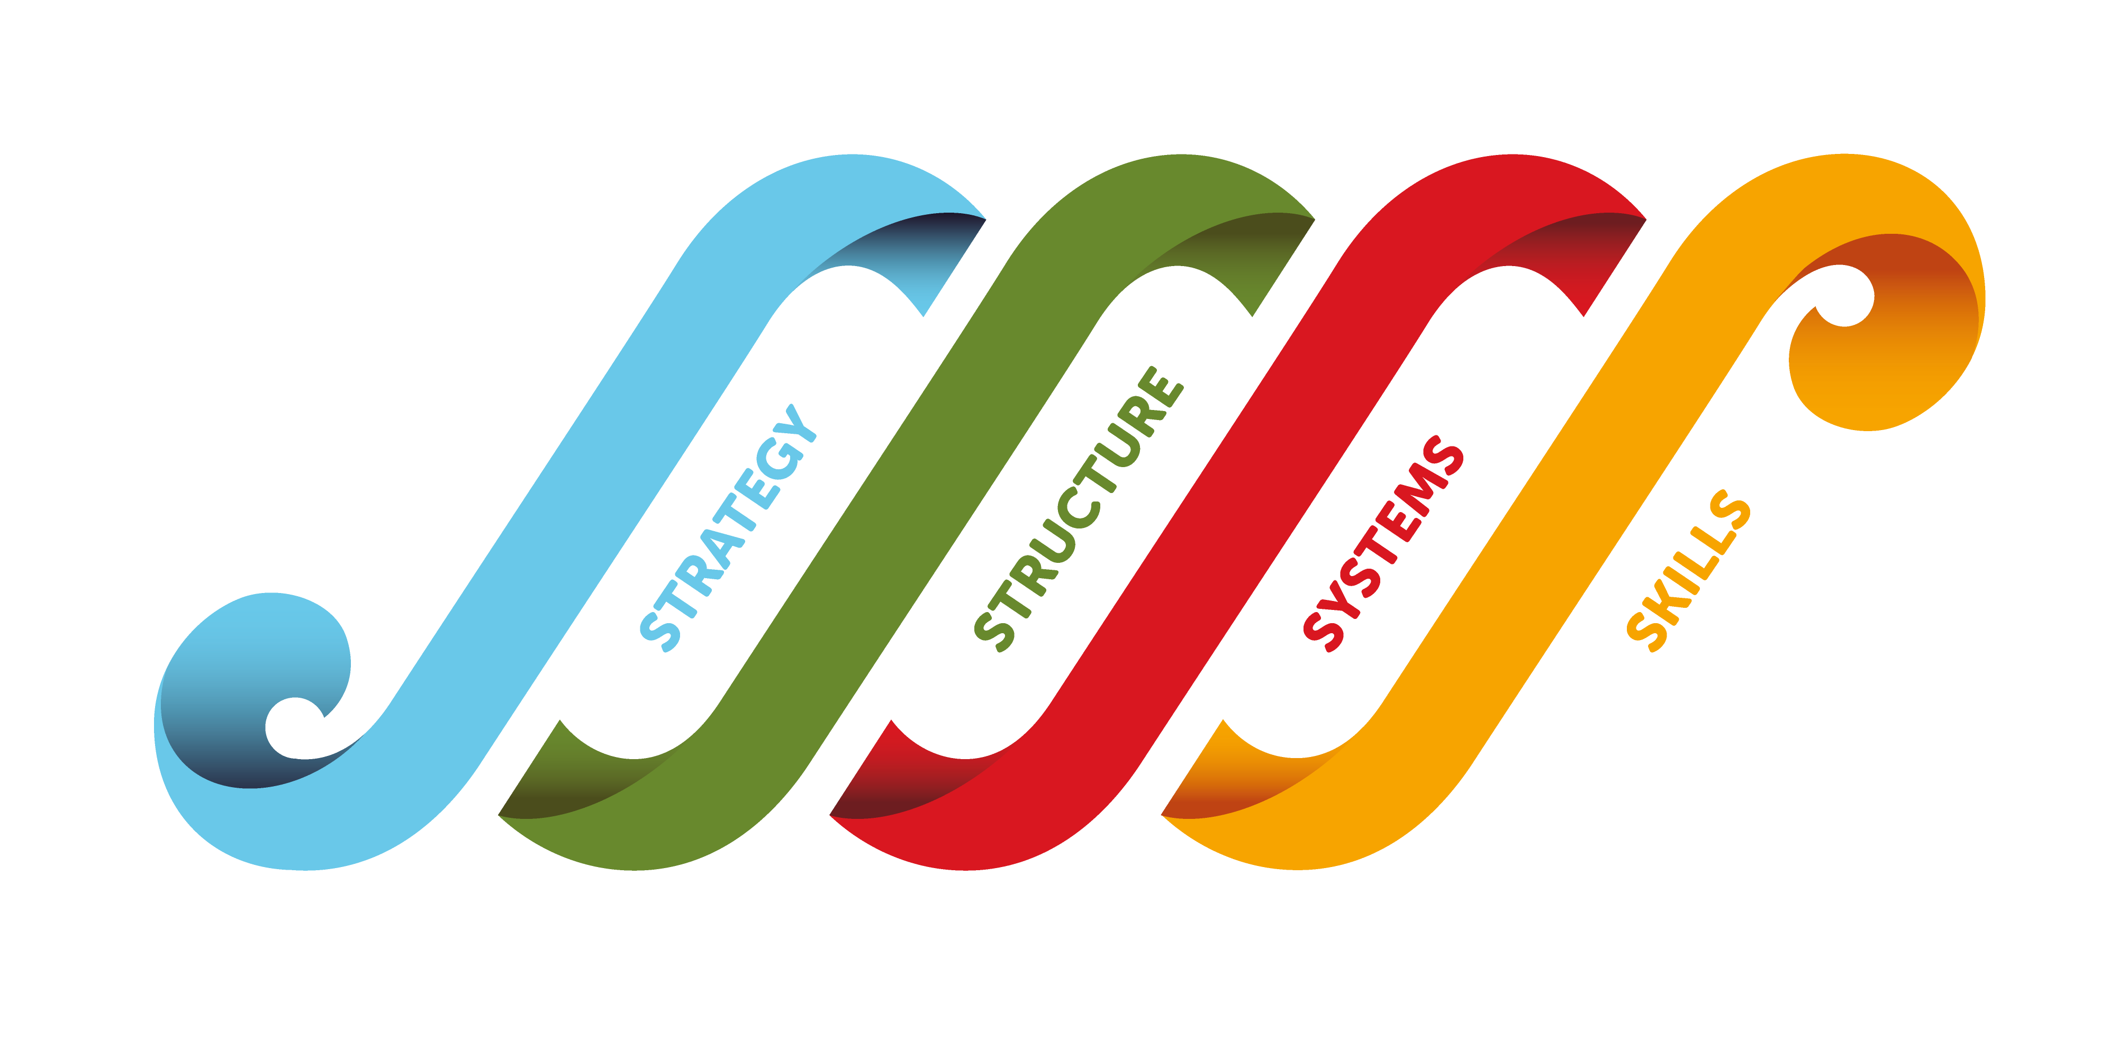
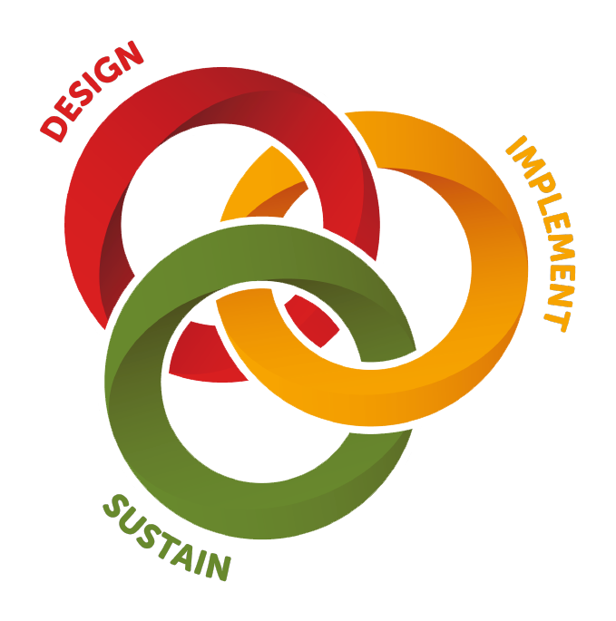
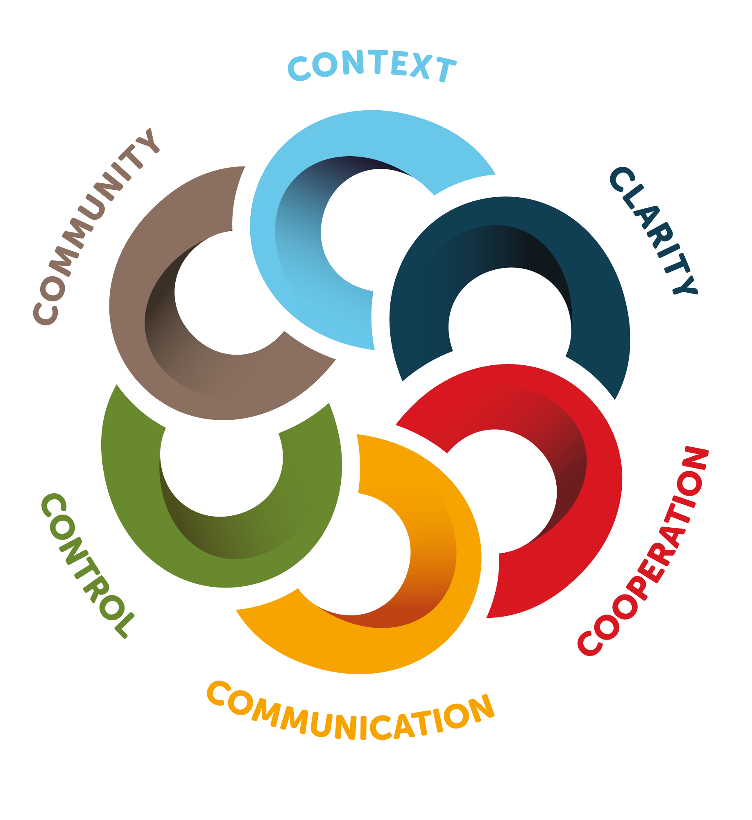
Why Global Integration?
Specialists in the globally integrated organization
Leading transformation –
The Four waves of change
We provide consulting, facilitation
and coaching services to support
executives who are leading
the transformation.

Building people capabilities – The Six C’s
We develop learning programs for people
working in matrix, virtual and global
organizations, based around our unique
six C’s framework. We deliver globally,
face-to-face, blended or online.

Embedding change
We help matrix, virtual and global
organizations embed change in their
ways of working and culture to implement
and sustain the journey to
a globally integrated organization

See more at www.global-integration.com
Since 1994 we have trained over 100,000 people in these areas and consulted with over 300 of the world's leading companies in more than 40 countries, including:

